**Friday, November 13**

**CBC Location**

**Room #123**

**12:00-1:00 p.m.**

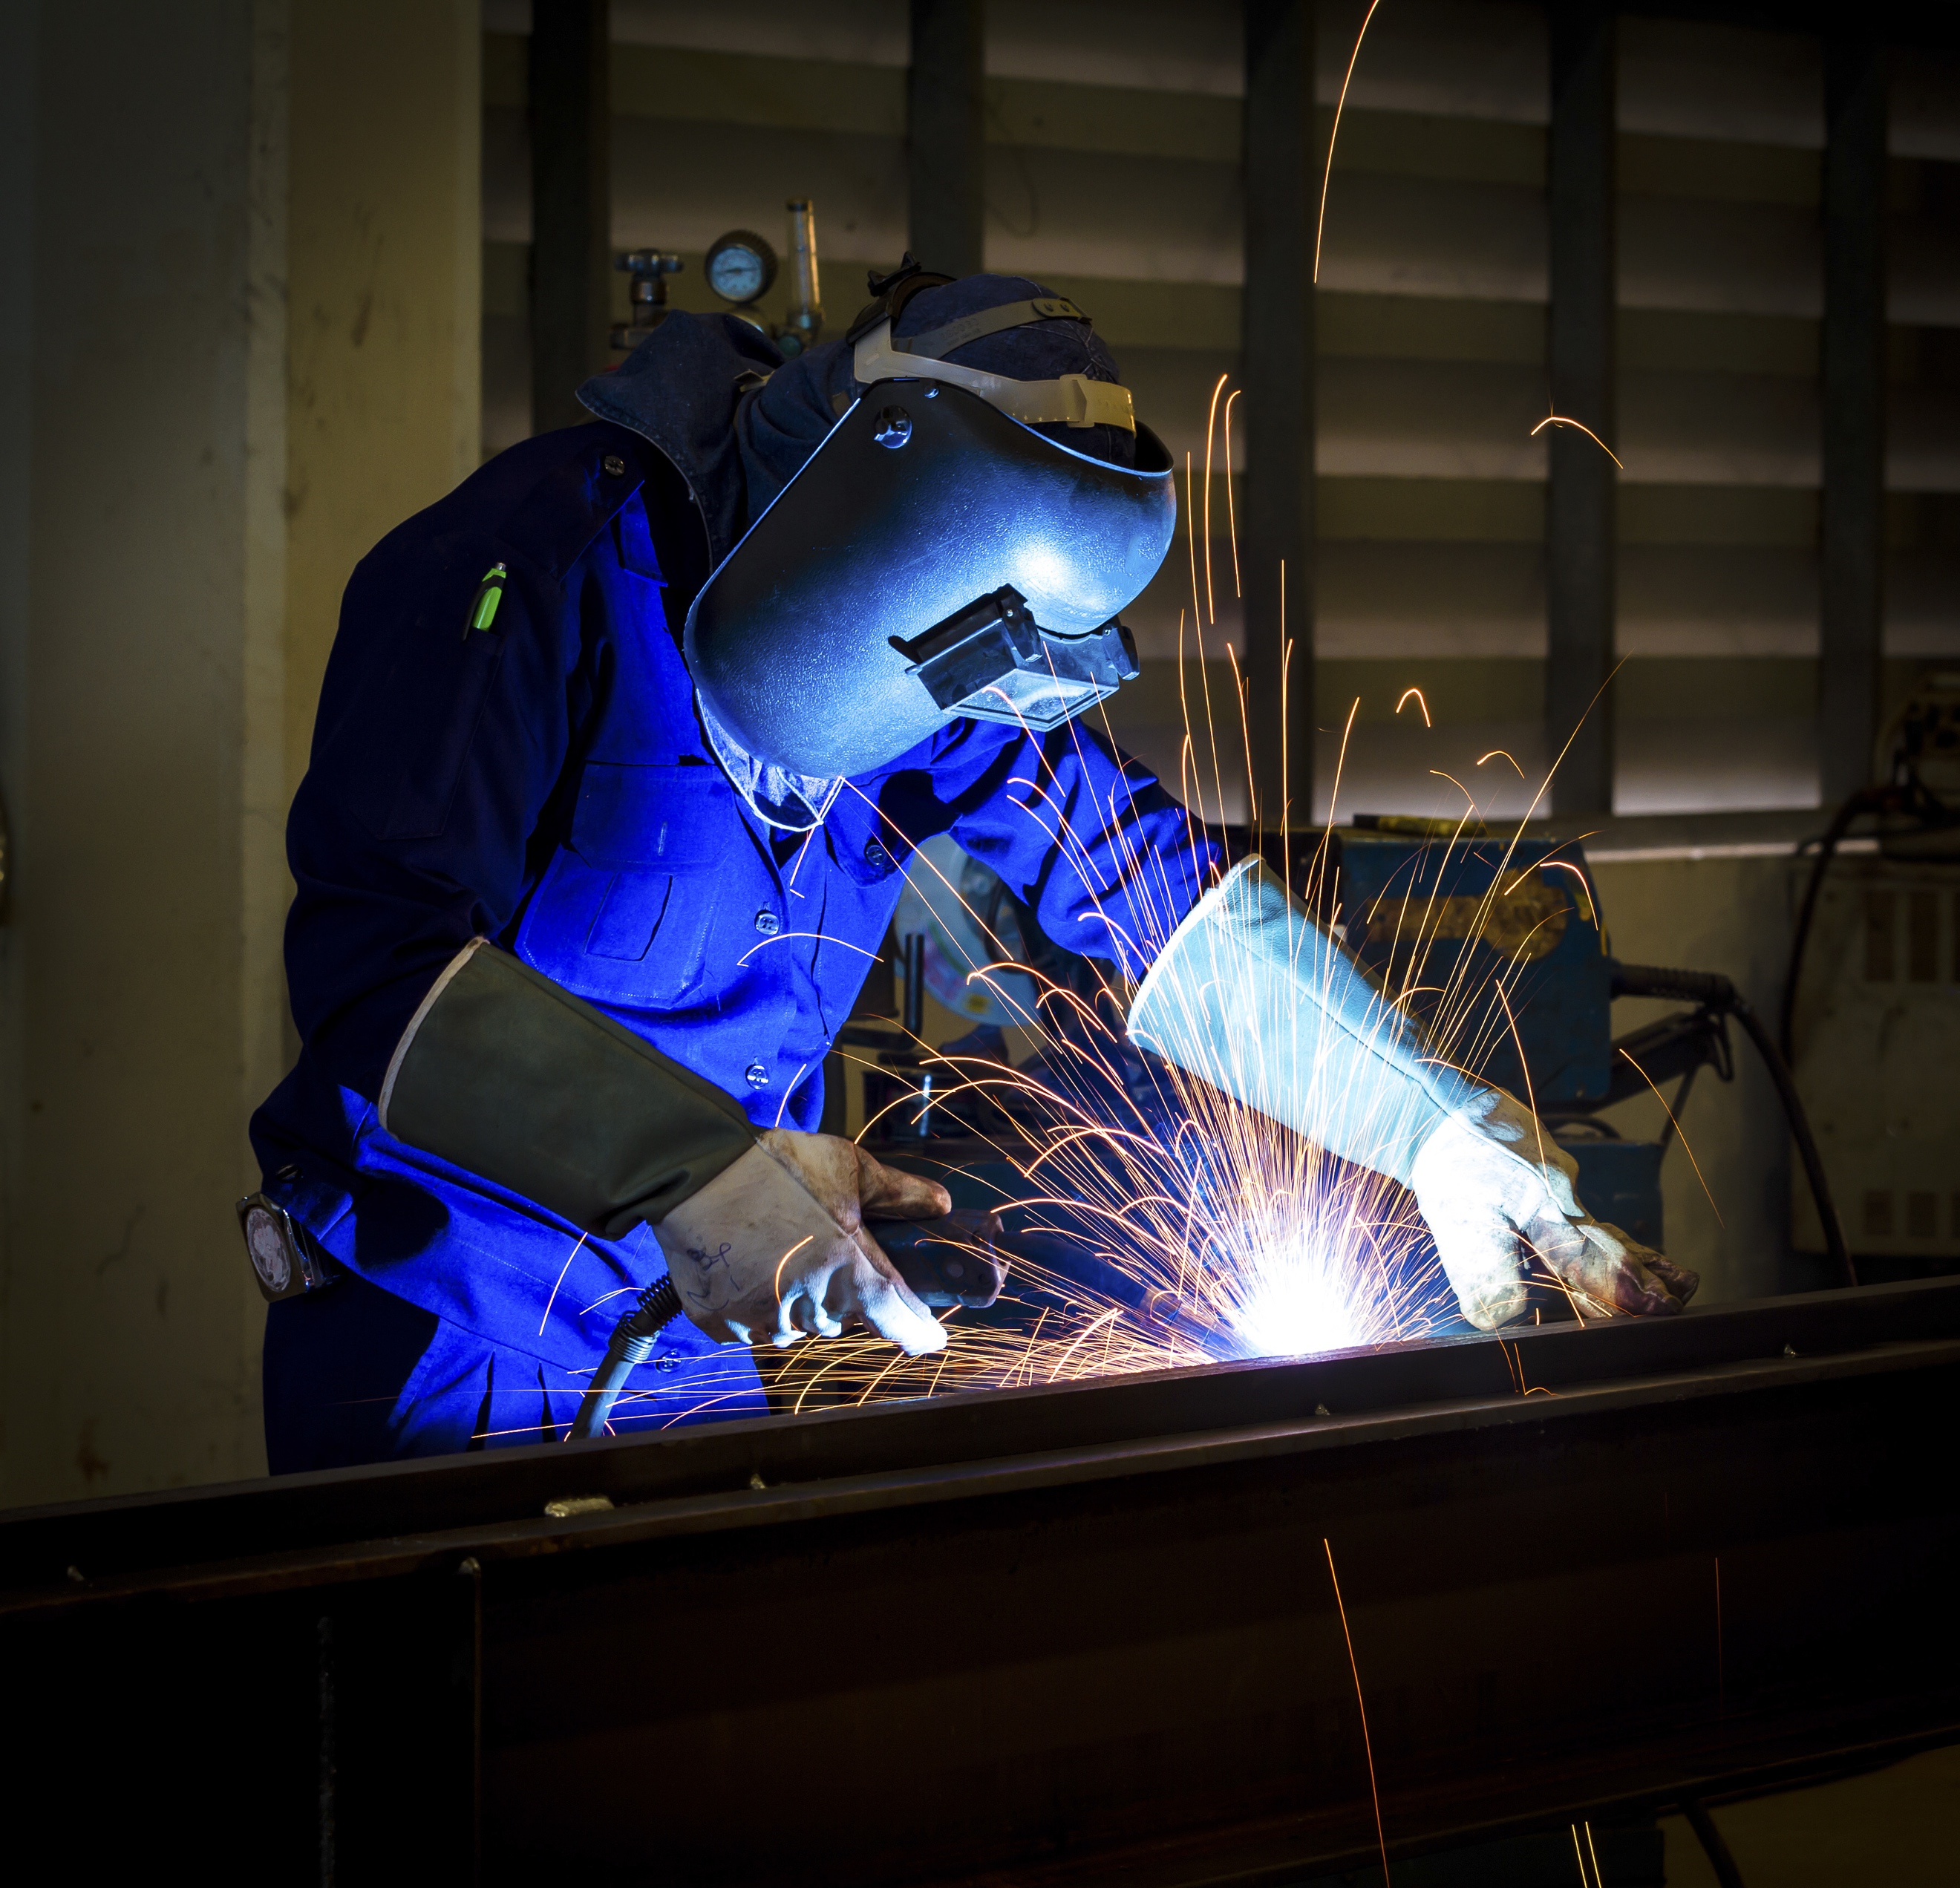

Use this space to highlight something unique or create a call to action about your event/workshop.

More details go here.

Don’t use clipart (please and thank you!) ☺

TO CHANGE OUT PHOTO 🡨

-Right click on photo and click “Change Picture”

-Select file from your computer

-If you need images, we have thousands at facebook.com/coastalbendcollege

-Images found in search engines are copyrighted, so proceed w/caution

**EVENT TITLE GOES HERE**

For more information, contact:

CBC Employee at (361) 555-5555 ext. 1234

cbcemployee@coastalbend.edu